
VICTORIA JUNIOR COLLEGE

JC2 PRELIMINARY EXAMINATION 2024

H2 GEOGRAPHY 9173/01
Paper 1

INSERT 3 hours

READ THESE INSTRUCTIONS

The Insert contains all the Resources referred to in the questions.

This document consists of 7 printed pages
Resource 1 for Question 1

Ferrero Group’s global supply chain

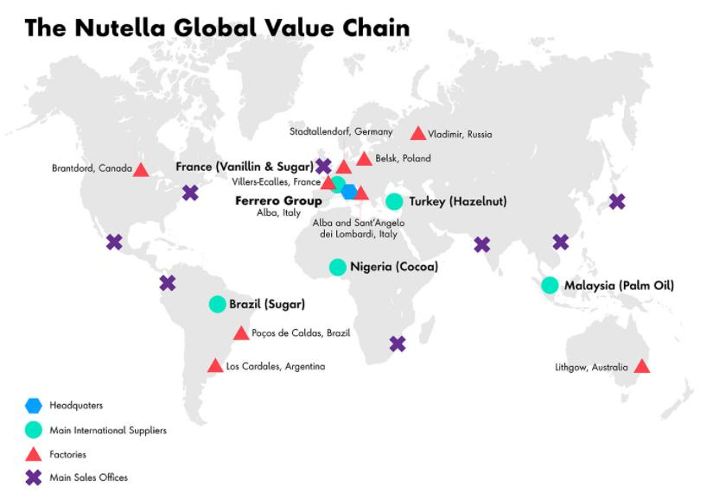
Resource 2 for Question 1

An article on the impacts of Nutella’s global production
Beloved hazelnut spread Nutella is a classic example of the benefits and costs of globalization.

Some 400,000 tons of it are produced every year by a supply chain touching almost every continent. Key ingredients such as cocoa, hazelnuts and palm oil are sourced from Africa, the Middle East and Asia, as producer countries boast about bringing their people out of poverty.
That network has come with consequences, though. Accusations that child labor was being used on hazelnut farms in Turkey and poor wages pushed Nutella’s parent Ferrero to ramp up traceability of its supplies in 2019.

The most controversial ingredient in that list is the palm oil. Since ingredients are listed on labels in order of quantity, as Nutella’s second ingredient, palm oil is a large component of the hazelnut spread’s recipe. The breakneck expansion of palm-oil production in Indonesia and Malaysia has come at the expense of vast swathes of rainforest, which Ferrero tries to counteract with sustainable sourcing and satellite monitoring of forest areas.
Not only does the destruction of rainforests release carbon dioxide emissions, but native peoples are being displaced for such plantations, and once functioning, these plantations are known to violate their workers’ human rights. To top it off, the biodiversity of these forests are being compromised, and orangutans and other species are becoming increasingly endangered from such vast deforestation.

Resource 3 for Question 1

Share of sales of top four confectionery companies by region, 2015

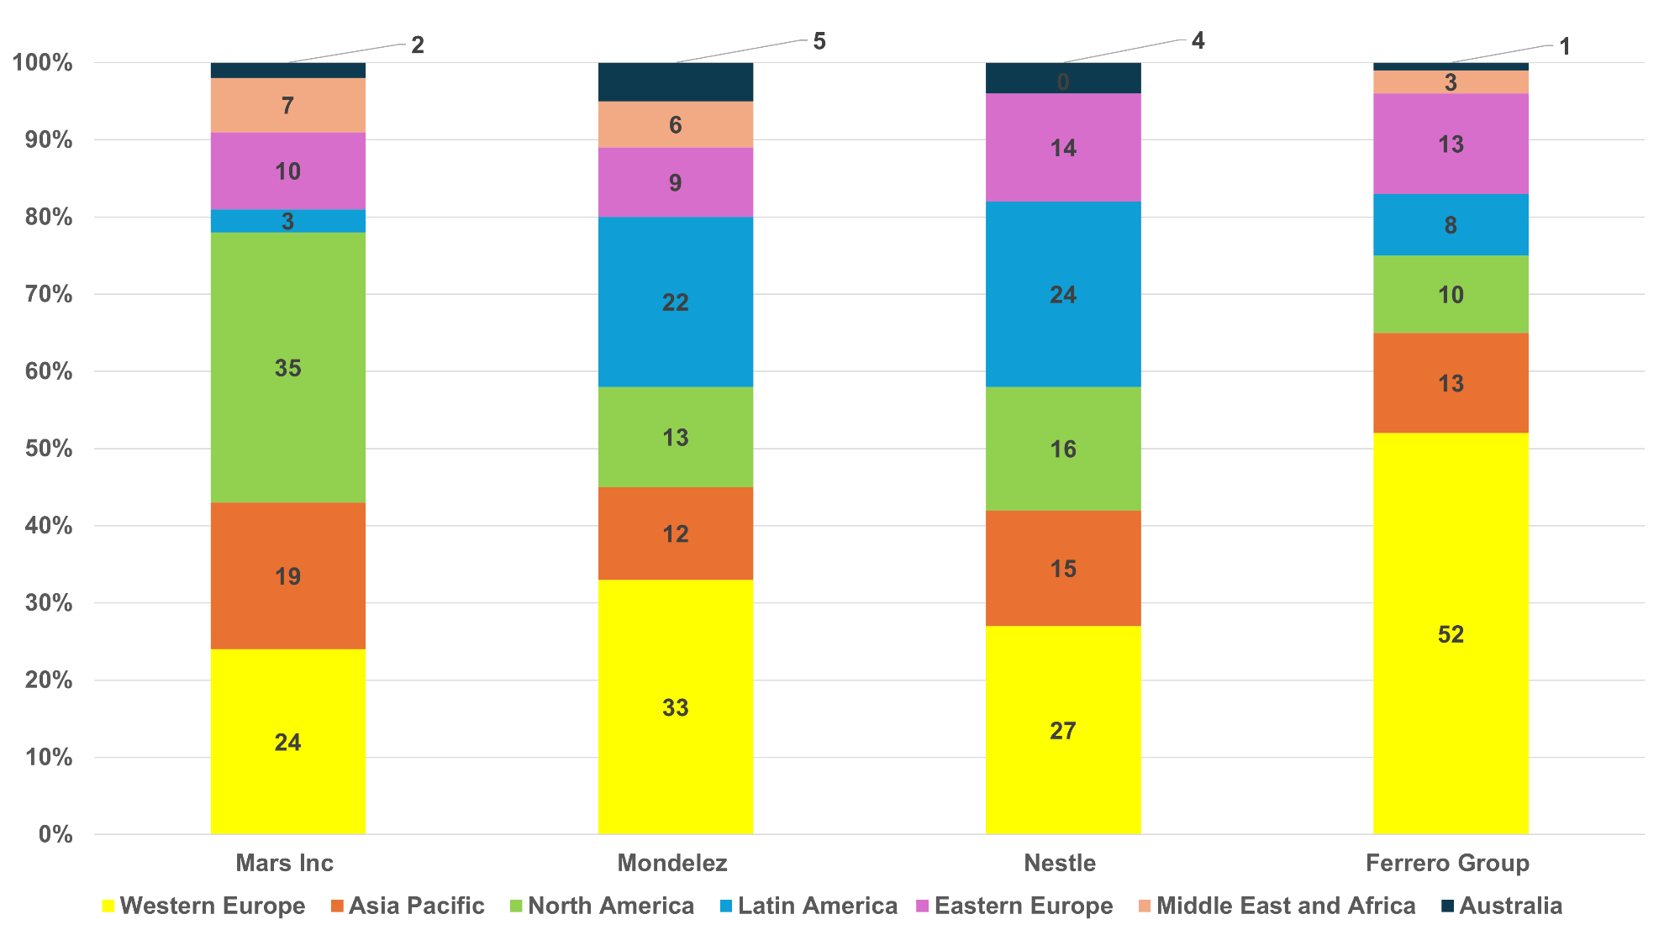

Confectionary  (Year Founded) | Mars Inc  (1911) | Mondelez  (1923) | Nestle  (1867) | Ferrero Group  (1946)
Country of Origin | America | America | Switzerland | Italy

Resource 4 for Question 2

Tower karsts in Kampot, Cambodia

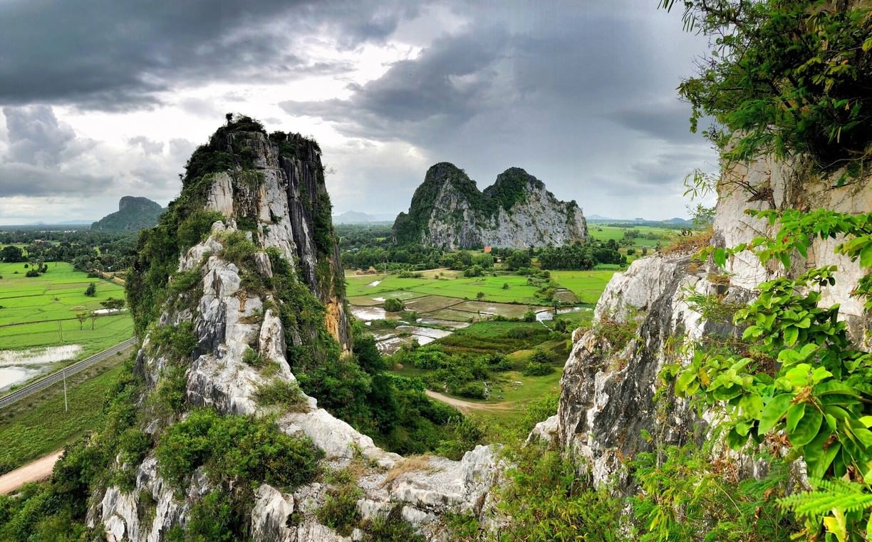

Resource 5 for Question 2

Climograph of Kampot, Cambodia

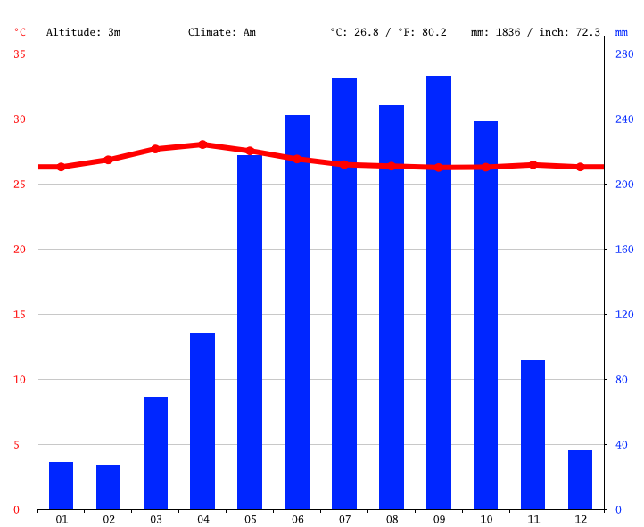
Rainfall
Temperature
Month

Resource 6 for Question 2

Phnom Chhnork, a Hindu temple in a limestone cave in Kampot

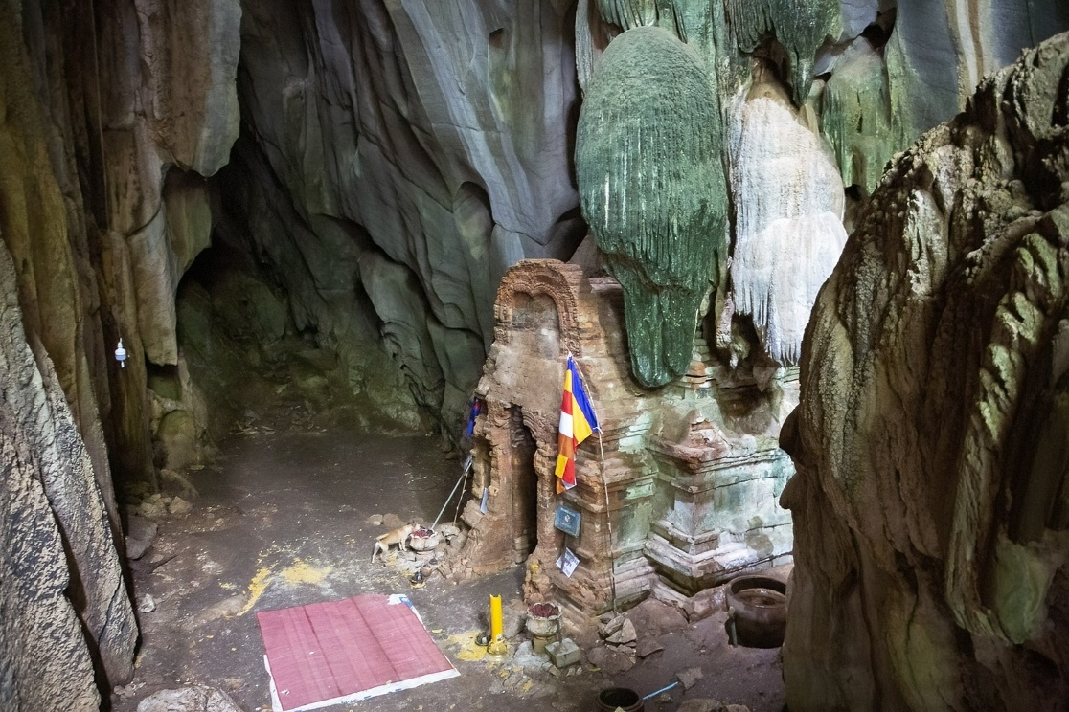

Resource 7 for Question 2

Adapted article excerpt on limestone quarrying in Cambodia

Millions of years ago, a cluster of coral reefs stood firm here as the water receded, leaving them surrounded by the marshy, mangrove-studded Mekong Delta. Today, these reefs have been carved into spiky limestone cliffs known as karsts that stand stark against the Cambodian landscape. The karsts are full of nooks and crannies that have nurtured highly specialized plants and animals found nowhere else. The caves are also important to humans, studded with small altars and temples as they are thought to be homes to neak ta or landscape spirits.

Soon, they will be gone.

A small group of scientists are now racing to document rare plant life in these limestone karsts before local companies quarry them to dust and grind them up for production of the cement that is fueling this country’s building boom. In interviews, the inhabitants complained that rocks being blasted off the mountains were falling on their homes and angering the local neak ta, who had to be propitiated with offerings of roast pigs. The destruction of karsts at the hands of cement companies, developers and tourists is a problem throughout the Southeast Asian region. But it is particularly acute here in Cambodia, where government regulation is lax and the state of local scientific knowledge fledgling.

Sources

Resource 1 | https://www.researchgate.net/figure/Nutella-global-value-chain-Ferrero-Group-Source-Adopted-from-De-Backer-and-Miroudot_fig2_310732174
Resource 2 | https://www.shrm.org/executive-network/insights/nutella-teaches-us-global-supply-chain-risks  https://planetforward.org/story/nutella-palm-oil-the-environment/
Resource 3 | https://www.snackandbakery.com/candy-industry
Resource 4 | Facebook – Tourism of Cambodia
Resource 5 | https://en.climate-data.org/asia/cambodia/kampot/kampot-26390/#climate-graph
Resource 6 | https://helloangkor.com/attractions/phnom-chhngok-pr/
Resource 7 | https://www.nytimes.com/2017/02/13/science/cambodia-karsts-plants.html

